Name: Fatma Anwar El sayed

Task: Data-Science Task for eT3 Graduate Internship 2022.

1. Import dataset:

Import pandas library to read and access data easily, then read dataset file

By using pd.read_csv which take path of the file

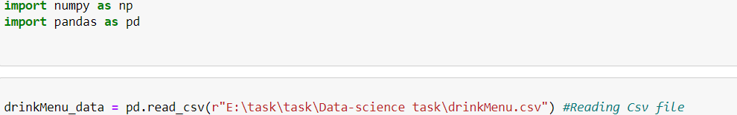

2-Data preparation: in this step I prepare data by Remove Duplication, Fill Null values and Drop unnecessary Columns.

-Remove duplication by using drop_duplicates() :

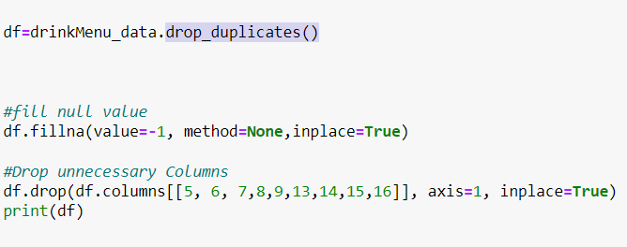

* Fill Null by using fillna function to fill all null values with -1 which consider an outlier and doesn’t affect my data.
* Drop unnecessary Columns : in this step I use drop function and selected columns which seem unnecessary as Dietary Fibre (g), Saturated Fat (g).

1. Data Visualizations: in this step I import seaborn as sns

* First figure show highest calories Drink:

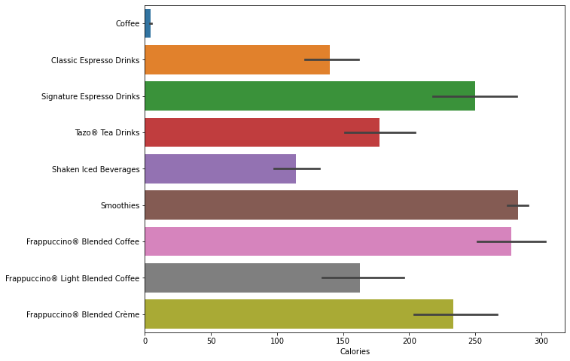

* Second Figure Show highest sugar Drink:

